CO -1 ,
EXP - 1 OB - 1
To generate and visualize basic continuous-time signals such as unit step, unit impulse, ramp, sinusoidal, and exponential signals.
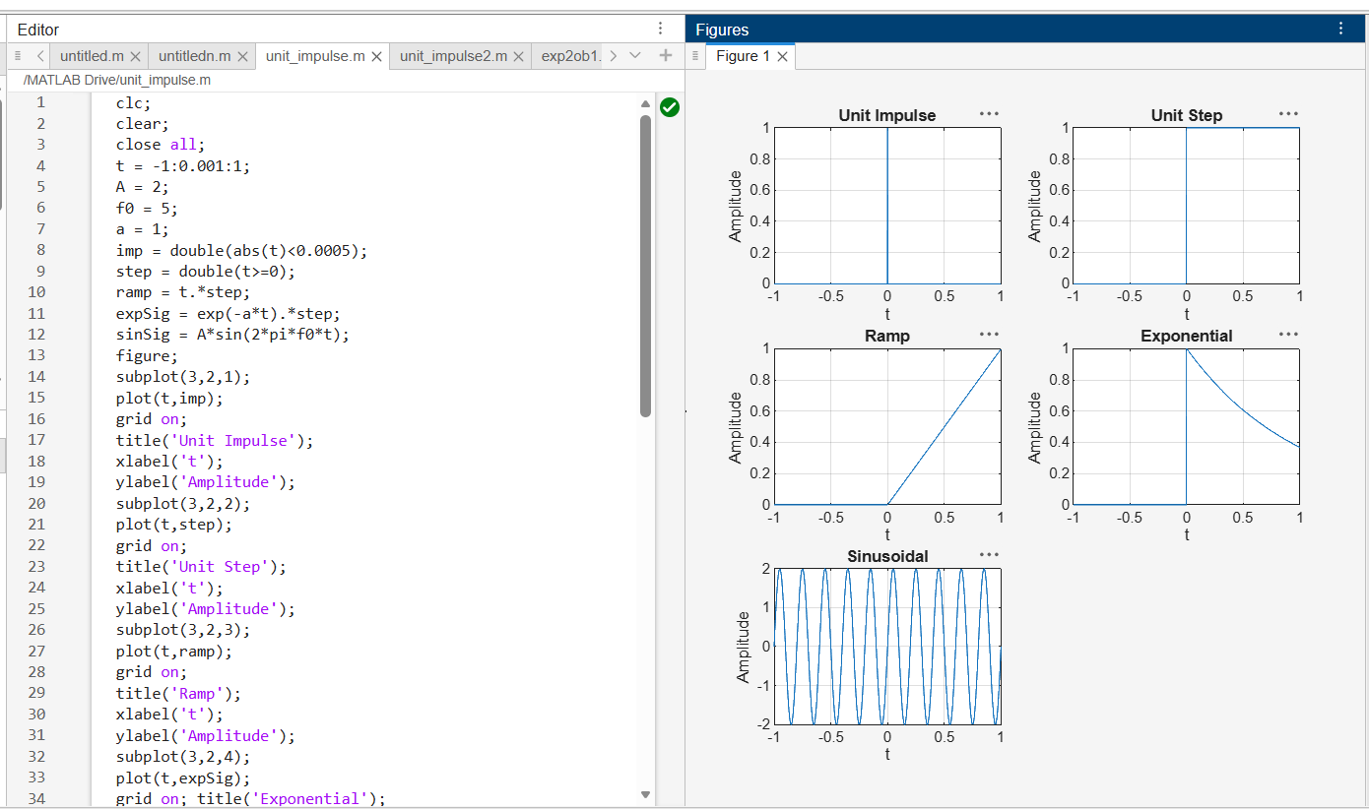
EXP – 1 OB – 2
To generate and visualize basic discrete-time signals and analyze their amplitude and time-index characteristics.
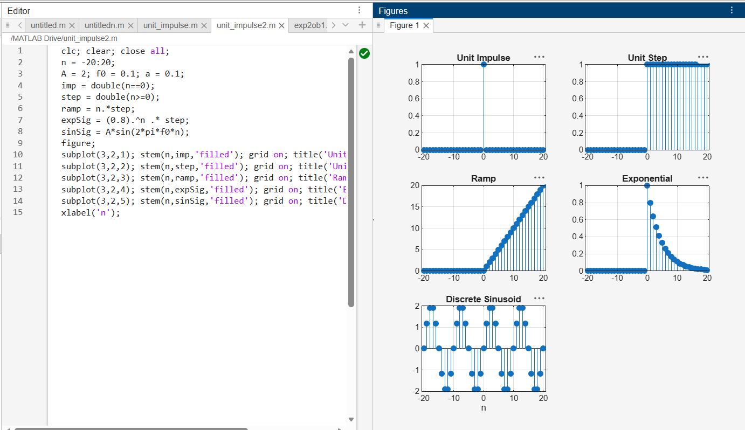
EXP – 2 OB – 1
To perform amplitude scaling and time scaling of continuous-time and discrete-time signals and analyze their effects on signal characteristics.

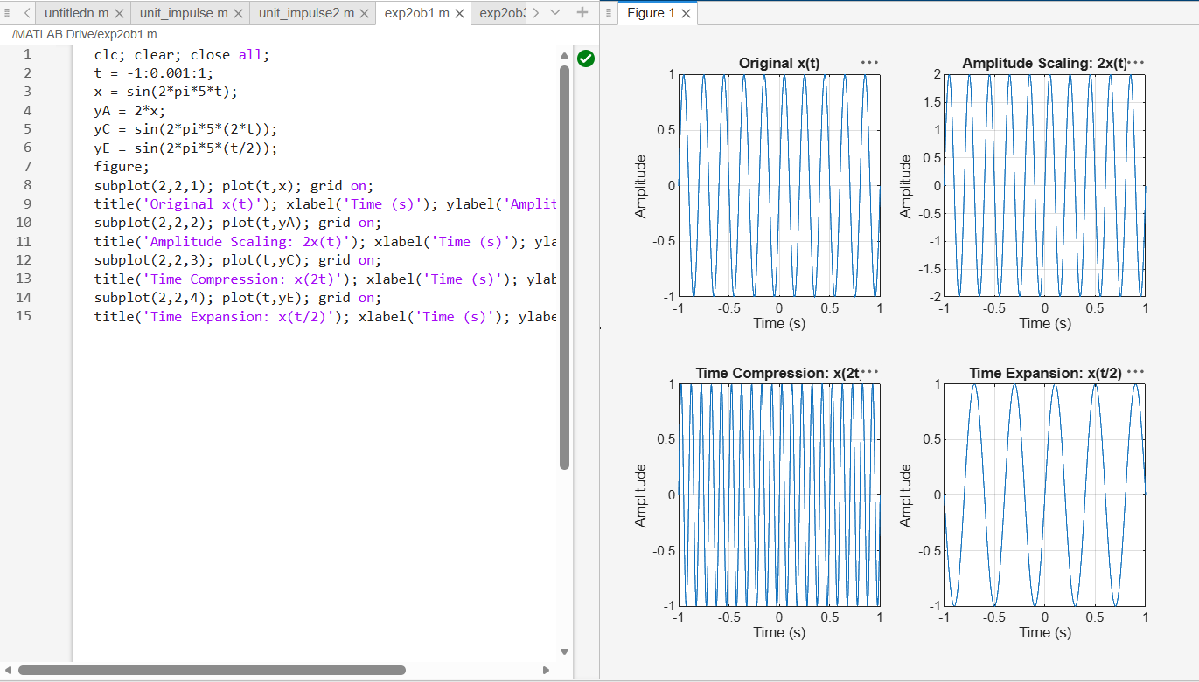EXP – 2 OB – 3
To perform addition and multiplication of two discrete-time sequences and analyze the resulting signal characteristics

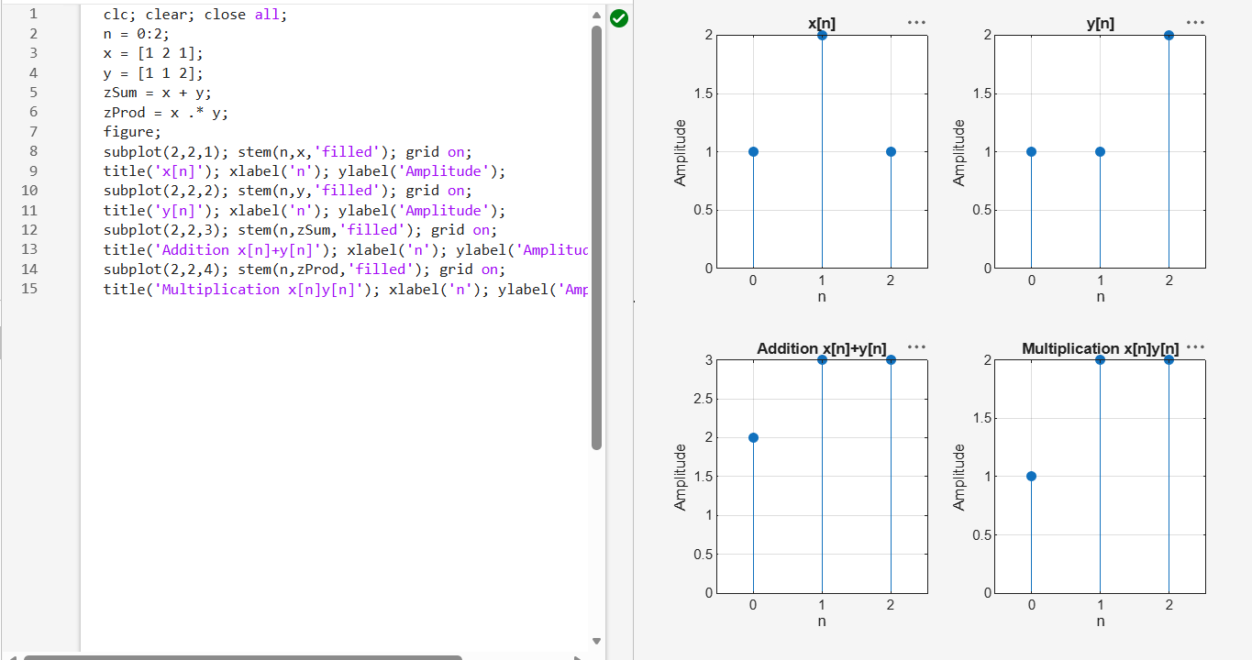

EXP – 3 OB – 1
To calculate the energy and average power of given continuous-time and discrete-time signals and classify them as energy signals, power signals, or neither based on their energy and power characteristics.

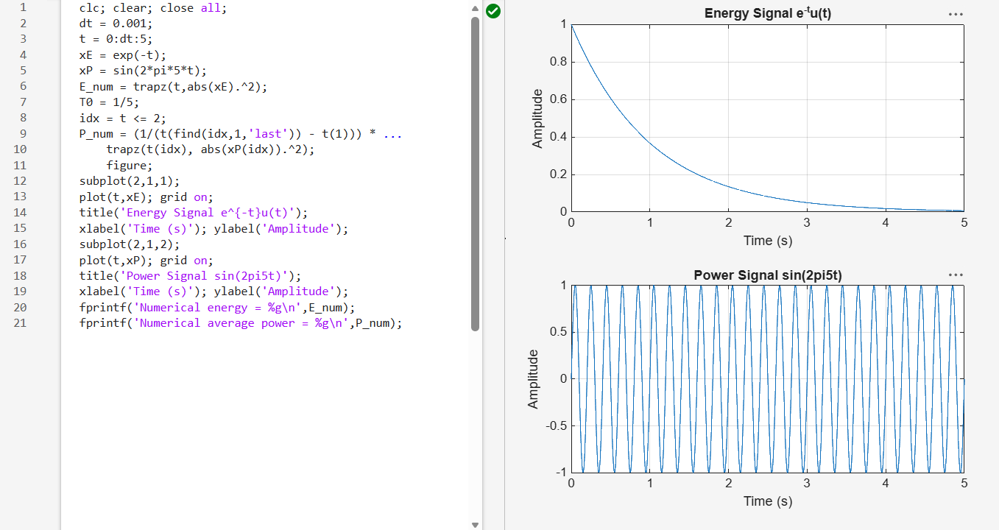EXP – 4 OB – 1
To verify the linearity and time-invariance properties of continuous-time and discrete-time systems using suitable input signals and system responses.
